**Audio Script Assignment – Nov. 20. 2017 – ARTH 370**

Work Discussed: Yahya ibm Mahmoud ibn Yahya ibn Abul-Hasan ibn Kouvarriha al-Wasiti. The Story, *“Of Zabid”*, Ink and Opaque Water Colour, 1236 – 1237, Baghdad

Folio #: 120v

Author: Josephine Schmitz-Burchartz

Student Number: 33661125

Total Time: 3.71Min

Total Word Count (Script): 475

Color Coded/Outlined for Zoom Representation: PAUSE, ZOOM IN – LEFT, ZOOM OUT, ZOOM IN RIGHT

|  |  |
| --- | --- |
| Begin Time: 0sec | End Time: 44sec |
| Transition Type - None | PAUSE |
|  |  |

*Sound Incorporation* – Retro Video Camera Starting

*Script:* In this image we will be looking at the story “Of Zabid” described in the 34th assembly and is dated in 1236 – 1237 in Bagdad from the Makamat of Hariri. The Characters that will be mentioned in this story include: Al Harith, a passionate traveler, who evidently keeps crossing paths with the secondary character, Abu Zayd, a chronic con man, who is also blessed with a literary gift – Abu Zayd, who is also the father of a young boy named Joseph, staging as a slave.

|  |  |
| --- | --- |
| Begin Time: 44sec | End Time: 69sec |
| Transition Type – ZOOM IN - LEFT | ZOOM IN – LEFT |
|  |  |
|  |  |

*Script:* As it is known, slaves had lots of mobility. Many where also slave soldiers, some could and would also arise on a hierarchical scale through providing particular services. Slaves were sourced from all over, but the Abbasid society brought many Africans into the slave network who consisted not only of slaves but also soldiers, and traders.

|  |  |
| --- | --- |
| Begin Time: 70sec | End Time: 91 |
| Transition Type – ZOOM OUT | PAUSE |
|  |  |

*Script:* In this story *Of Zabid*, which is shown here, Al-Harith comes to the Slave Market in search of a new one since his well-established emotional connection and loyalty with his pervious slave is now discontinued, due to the death of him.

|  |  |
| --- | --- |
| Begin Time: 92sec | End Time: 143sec |
| Transition Type – ZOOM IN RIGHT, PAUSE | PAUSE 🡪 ZOOM OUT |
|  |  |

*Script:* Al Harith goes unsatisfied at the slave market till he learns about a slave merchant who approaches him with a veiled face. The salve merchant then proposes to Al Harith the young slave he has for sale, which he holds by his upper right arm, as he attempts to persuade Al Harith how good of a slave opportunity he has in front of him, mentioning all the great things the slave can do. As Al Harith looks at the slave who Abu Zayd holds by his arm, the salves beauty encompasses him. Al Harith asks the slave for his name, but he does not answer.

After Abu Zayd convinced Al Harith, about the beautiful boys qualities, he purchases him in lawful means and prices of a servant.

|  |  |
| --- | --- |
| Begin Time: 144sec | End Time: 210sec |
| Transition Type – ZOOM OUT 🡪 PAUSE | PAUSE 🡪 END |
|  |  |

*Script:* After the purchase goes through and Abu Zayd gets his transaction from Al Harith, he immediately leaves. Then to Al Harith the boy spoke aloud, “I am Joseph” and tells Al-Harith that he is a freeborn individual not a slave, admiting his freedom to him therefor Al Harith lets him go. Al Harith finds himself in dismay because he realizes he was conned by Abu Zayd once again, as a salve merchant, and that the boy who posed as a slave was Abu Zayd’s son.

Al Harith then swims in a pool of shame, that he fell into the trap of purchasing a servant from a vialed face man, and then loosing a bargain. Al Harith evidently comes onto emotions of exploitation, because of Abu Zayd’s power and whit over him.

*Sound Incorporation:* Crowed Voices Faded In & Out

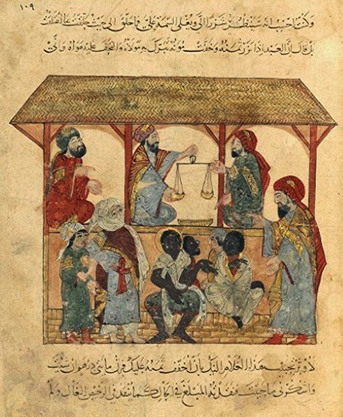

NEXT PHOTO DESCRIPTION, No Voice Over, Time: 210sec – 223sec

END.

Thank You So Much!! – Josi Schmitz-Burchartz